User Guide 56 Adding Owners Corporation schedule details
Purpose of this User Guide
The purpose of this User Guide is to help Applicant Contacts about supplying Owners Corporation (OC) schedules in SPEAR.
Who should read this?
Primary audience: Applicant Contacts
Introduction
SPEAR provides Applicant Contacts with the ability to supply their OC data in XLSX spreadsheet format. Once uploaded, SPEAR will validate and generate the OC Schedule from the data and attach it to the plan PDF. A mandatory action ‘Add Owners Corporation Details’ is displayed once the plan has been supplied for certification-inclusive applications, and an optional action for permit only applications.
This is not required for ePlan applications as the OC data is already included in the ePlan file.
56.1 How do you add an OC schedule?
For certification-inclusive applications, a mandatory action ‘Add Owners Corporation Details’ will be displayed after a plan is attached to the application. This will only be displayed for dealing types that can create or modify OCs.
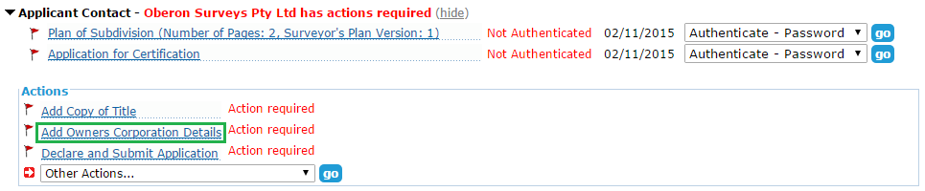

For permit-only applications, an optional action ‘Add Owners Corporation Details’ will be displayed after the plan for endorsement is attached to the application.
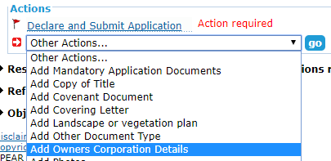

For certification-inclusive applications, you will be required to select whether an OC schedule is required, and for certain dealing types, whether it relates to a new OC or modifies an existing one. Alternatively, you can indicate whether an OC schedule has already been supplied as part of the plan PDF or is not required at all.
If an OC schedule is required and is being provided within a spreadsheet, browse and attach the XLSX file.
Before submitting, you must also specify whether you want the OC schedule appended to the Plan for Endorsement. This option is selected by default, untick if you do not want it attached.

NOTE: The OC schedule spreadsheet template can be downloaded from this screen.

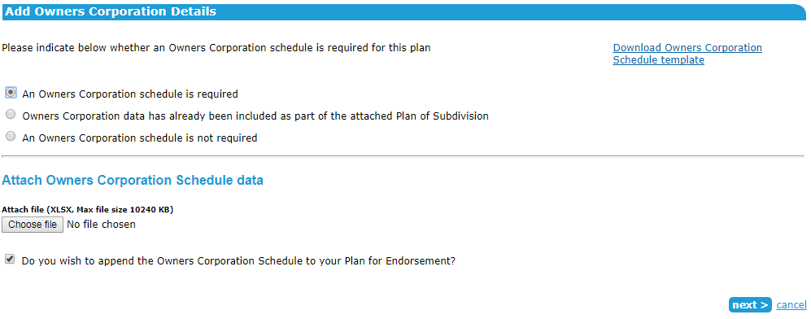

56.2 Completing the OC spreadsheet
For information about completing the OC schedule spreadsheet template, see Appendix 4 of Technical Note 4.
56.3 How to complete the OC details (certification-inclusive applications only)
The following additional details are to be supplied by the Applicant Contact. These will be provided to the lodging party either in SPEAR (electronic lodgments) or when releasing for lodgment (paper lodgments).

Address for OC service of notices
Select ‘Enter new address’ from the drop-down list and enter the postal address of the OC to which notices are to be sent.

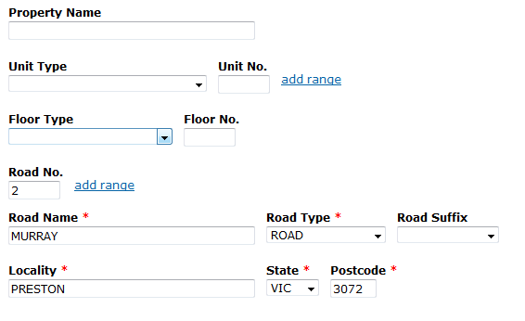

NOTE: A ‘care of’ or ‘post office box number’ is not an acceptable address.

If you are adding an additional OC, the previous address entered for the first OC can be selected from the drop-down list.

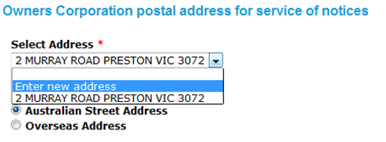

Purposes of the OC

Insert a statement detailing the purposes of the OC. The purposes for which an OC exists will vary, but the following suggested wording may be suitable for an unlimited OC:

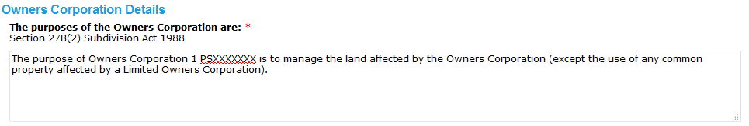

Basis for allocation for lot entitlement and lot liability

Select a statement detailing the basis used for the allocation of lot entitlement and liability from the drop-down box or enter your own in the text box below.

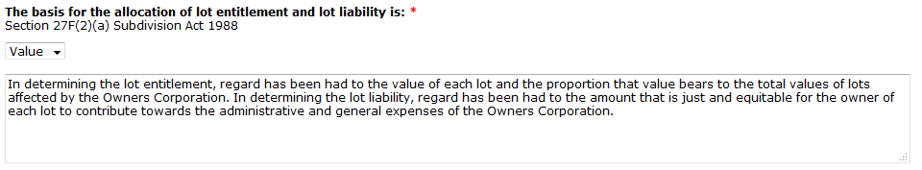

Details of the limitations

For limited OCs, enter the details of the limitations in the text box provided.

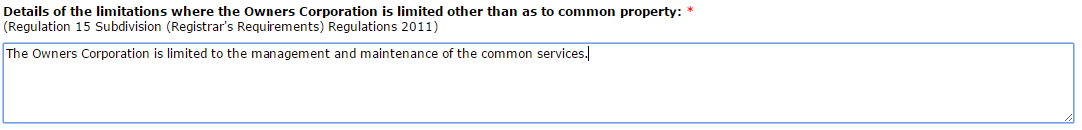

Additional functions or obligations

If applicable, enter the additional functions or obligations in the text box provided.
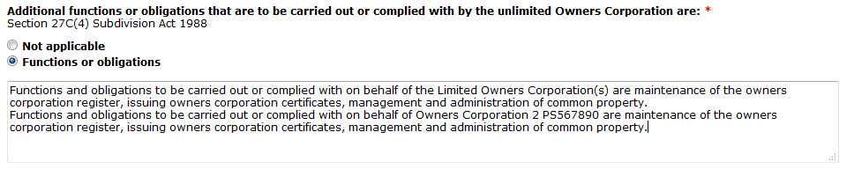

Once the additional information has been provided, SPEAR will generate the OC schedule and attach it to the plan PDF. The plan is then ready to be authenticated.
.
56.4 Adding an additional OC schedule
Once the first OC schedule has been added, select ‘Add Owners Corporation Details’ from the ‘Other Actions’ drop-down list and complete the steps above to add an additional OC schedule.
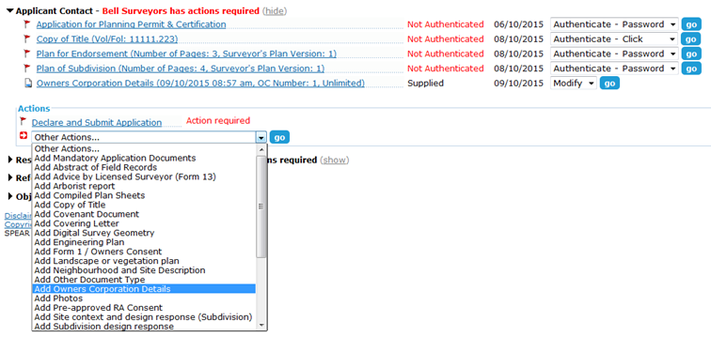
Need more information?
Further information on this topic can be found by:
- Visiting the SPEAR website www.spear.land.vic.gov.au/SPEAR.
- Contacting the SPEAR Service Desk on 9194 0612 or email spear.info@delwp.vic.gov.au
- Selecting the Help link in the relevant area of the SPEAR system.

